**Daily worklog (19-06-2020)**

**After plotting different kinds of plots, save all the individual plots on your hard disk.**

1. Get the basic description from the data
2. Get total profit of all months and show line plot with the following style properties. Generated line plot must include following style properties: –

* Line Style dotted and Line-color should be red
* Show legend at the lower right location.
* X label name = month number
* Y label name = sold units number
* Add a circle marker.
* Line marker color as read
* Line width should be 3

1. Read all product sales data and show it using a multi line plot
2. Read toothpaste sales data of each month and show it using a scatter plot
3. Read face cream and face wash product sales data and show it using the bar chart
4. Read Bathing soap, face wash of all months and display it using the Subplot
5. Read the total profit of each month and show it using the histogram to see most common profit ranges

Prepare a documentation of all the above questions

* Write the question in the document and paste the code snippet of your solution in the document
* After generating the plots, paste the plot into the document and write down your observations below the plots.

**Importing the required libraries**



**Description of Data**

Describe gives the information about like count,mean,min value in data set and max value in data set,25%,50%,75% of each column in the data set.

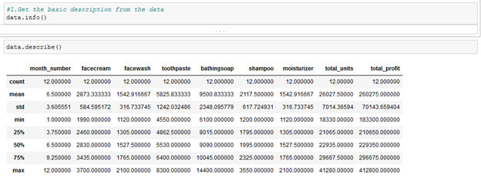

**Plot a Line graph :**

We have plotted graph for “month_number”as x and “total_profit” as y.

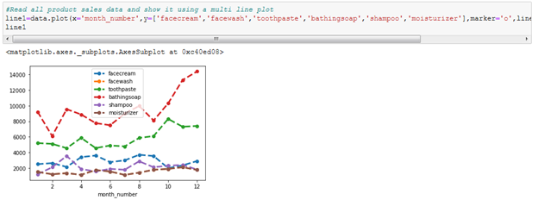

As Observed above:

1. Profit in February Month is less.
2. Profit in November Month is more.
3. Profits increased more from September to November and gradually dropped from November to December.

**Multi line Plot for all product sales data**

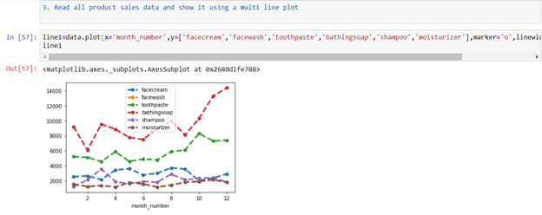

As Observed above:

→ Sales are more for bathing soap product for all months

→ Moisturizer,Shampoo,Facecream are in low level of the graph in terms of Sales

**Scatter Plot for toothpaste sales data of each month**

Scatter plots are used to plot data points on a horizontal and a vertical axis in the attempt to show how much one variable is affected by another

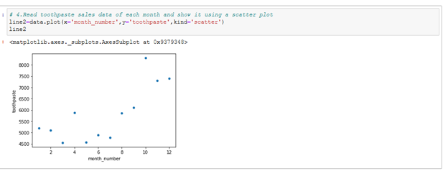

As Observed above:

→ Toothpaste has Least Sales in March and May

→ Toothpaste has Highest Sales in October

**Bar Chart (Month vs Facecream and Facewash Product’s Sales)**

A bar chart or bar graph is a chart or graph that presents categorical data with rectangular bars with heights or lengths proportional to the values that they represent. The bars can be plotted vertically or horizontally.

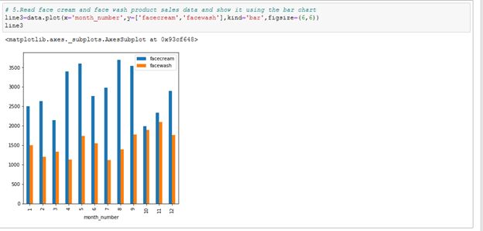

As Observed above:

→ Face Cream Sales  are more in the month August

→ Face Wash Sales are more in the month November

→ Face Cream Sales are less in the month October

→ Face Wash Sales are less in the month April and July

**Subplot for Bathing Soap and Face Wash Sales of all months**

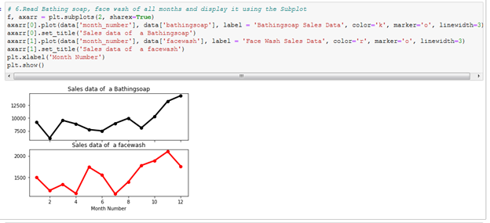

As Observed above:

→ In sales data of Bathing Soap, February Month has least the Sales and December has the highest sales

→ In sales data of Face wash, July Month has the least Sales and November Month has the Highest  sales

**Histogram for total profit of each month**

 A histogram is a graphical display of data using bars or bins of different heights. In a histogram, each bar groups numbers into ranges. Taller bars show that more data falls in that range. A histogram displays the shape and spread of continuous sample data.

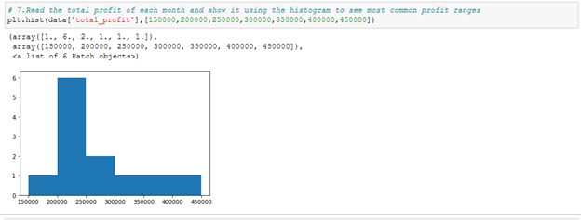

→ Mostly the Profits are in the range 200000 to 250000

→ Rarely the Profits gained are in the range 150000 to 200000 and 300000 to 450000